Session 05 - Running an RSA Cipher Demonstration Wei Cui

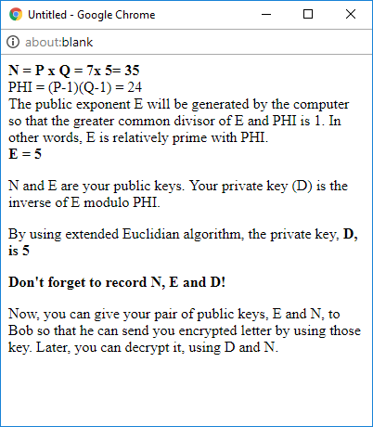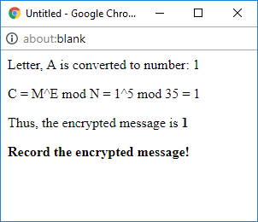

Fig. 1. Screenshot of (Left) Step 6: P = 7 and Q = 5 and (Right) Step 11: Encrypted message.

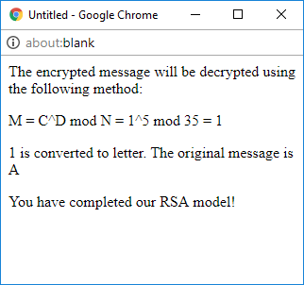

Fig. 2. Screenshot of Step 16: The message successfully decrypted.